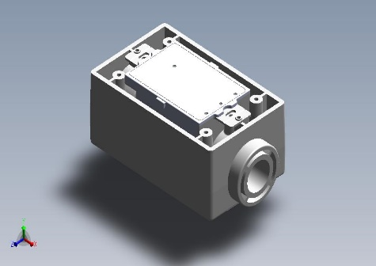

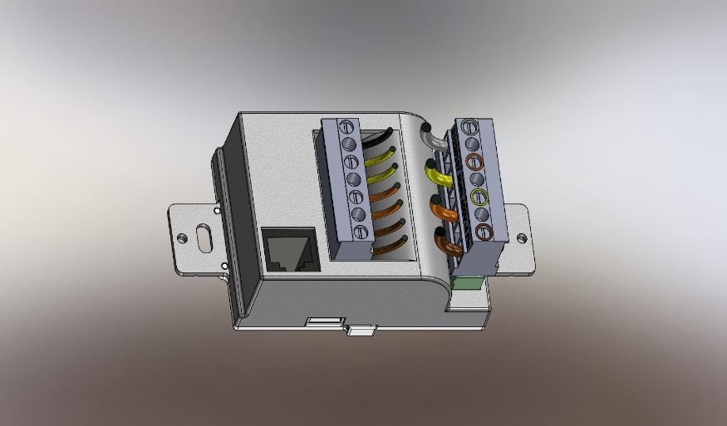

**Specifications:**

|  |  |
| --- | --- |
| **Type** | Three Phase Four Wire,  Four Quadrant Communicating  Precision LoRa Meter |
| **Volts** | 1, 2, or 3 Phase  100 – 377 VAC L-N,  < 600 VAC L -L |
| **Frequency** | 50 / 60 Hertz |
| **Current** | 1, 2, or 3 Phase 1 A (5 A Max) |
|  | External CT – **CURRENT:5A** |
| **Accuracy** | 0.2 % |
| **Measured Values** | **Instantaneous Polyphase**  **Readings Stored in NV RAM**  **Active:**  Power (kW), Demand (kW),  Energy (kWh) (+/-),  **Reactive**  Power (kVAR), Demand (VAR)d)  Energy (kVARh) (+/-),  RMS Voltage, RMS Current,  Frequency, Power Factor,  Temperature |
| **Pulse Constant:** | **10,000 Imp. / kWh** |
| **Interfaces:** | **LoRa**  Serial / Pulse **Sensor** |
| **Compliance:** | **UL ANSI IEC / CE** |
|  |
| **Temperature** | -25 to + 55 deg. Celsius |

The **CWS uMeter** is a **Compact, Cost-Effective Electrical Meter and Submeter** meeting US and International Safety Requirements which provides LoRa Access to **Three Phase** Precision Active and Reactive Power, Energy and sensor information by an in-built AWS Cloud Portal

Meets US Department of Energy – “Wireless Meter Challenge”. specifications

As a Three Phase, Four Wire Meter, it mounts in any Single-Gang Junction box - indoor or waterproof - the **CWS uMeter** can meter electrical loads from 1 to thousands of Amperes over Voltages from 120, 208, 277, 377, 480 or 600 VAC 50 / 60 Hz.

* It can be read by any LoRa Gateway device.
* Up to 10,000 Meters and Displays Can be reported to AWS cloud
* It has an internal Website Portal to configure it or it may be configured from a handheld cellular phone or pad.
* You can download hourly, daily, or monthly report – which can be read directly to spreadsheet or data base!
* It can send your server a JSON interval reading message with fourteen measured variables accurately at intervals from 1 minute to 1 month

|  |  |  |
| --- | --- | --- |
| J 1 (UL 600V) | | |
| 1 | PH A | BROWN |
| 2 | PH B | ORANGE |
| 3 | PH C | YELLOW |
| 4 | NEUTRAL | GRAY |

[1]

*CHALLENGER*

**ONE, TWO OR THREE PHASE - FOUR QUADRANT WIRELESS PRECISION ELECTRIC METER**

* 3 X 80 – 600 VAC 50 / 60 HZ
* 3 X 1.0 (5) Ampere input for use with External Current Transformers
* 0.5 % ANSI / IEC Accuracy Cl 0.5S
* WI-FI™ 802.11n 2.4 GHz
* kH = 10,000 IMP / kWh (.1Wh)

 

|  |  |  |  |
| --- | --- | --- | --- |
| J 2 (UL 300V) | | | |
| 1 | CT A + | **2** | CT A - |
| 3 | CT B + | **4** | CT B - |
| 5 | CT C + | **6** | CT C - |
| 7 | LV AC (<300 V) |  |  |

**Approx Mechanical. Subject to final dimension after product release**

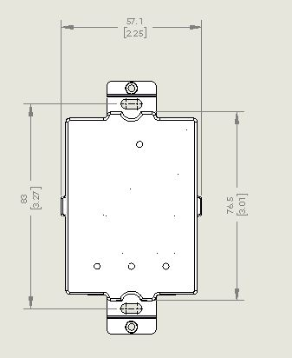

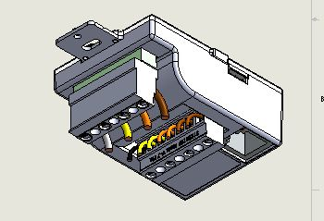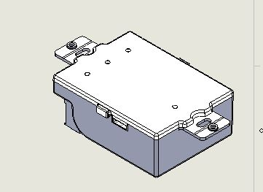

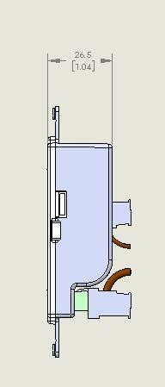

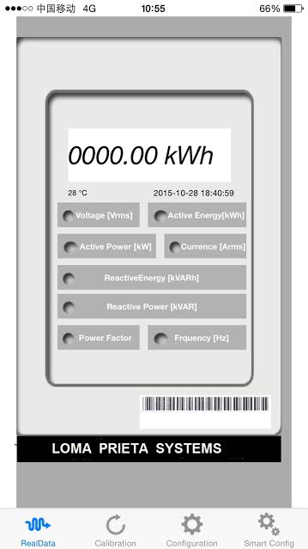

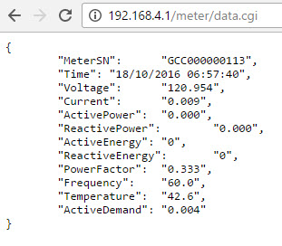

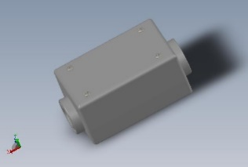

1.